**SGP PROJECT PAPER**

**CAR RENTAL WEBSITE**

Dev Bhavsar   
*Department of IT*  
*Charusat University*Changa, Gujarat,India  
[20IT007@charusat.edu.in](mailto:20IT007@charusat.edu.in)

Tusharkumar Parmar  
*Department of IT*  
*Charusat University*Changa, Gujarat,India  
[19IT079@charusat.edu.in](mailto:19IT079@charusat.edu.in)

**ABSTRACT:-**

The Car Rental Website is made to manage all the car rental activities at one time. It provides the details and information regarding all the cars available to rent. The website will provide the activities in quick and easy manner. It’s a user friendly website. User can also get the driver’s information through this platform.

**INTRODUCTION:-**

The main objective is to digitally organize and automate the whole car rental system and reduce the manual work of mantaining information. The user will also get an advantage as the website will consume less time and he/she will be able to digitally rent a car. The website will maintain all information of cars, Passengers, drivers, booking ,etc. Only the administrator is guaranteed the access.

**PROBLEM STATEMENT:-**

A Car Rental System is where a car is to be rented at a price. A Car Rental System through manual paper work is a very time consuming and inefficient way.

**PROPOSED SOLUTION:-**

Creating a user friendly and automated Car rental website that allows user to register and rent a car online. It makes the process easier for the user. This method also improves client retention.

**TOOLS USED:-**

1. Web Browser – It is a software application for accessing the local website.
2. Wix – It is a cloud – based webisite maker which helps in designing and web-hosting.
3. MySql- It is a database software which consists of many SQL server which supports many and different kinds of back-ends.
4. Github – It is a git repository hosting service which provides web-based interface

**FLOW OF WEBSITE:-**

1. **HOME PAGE**

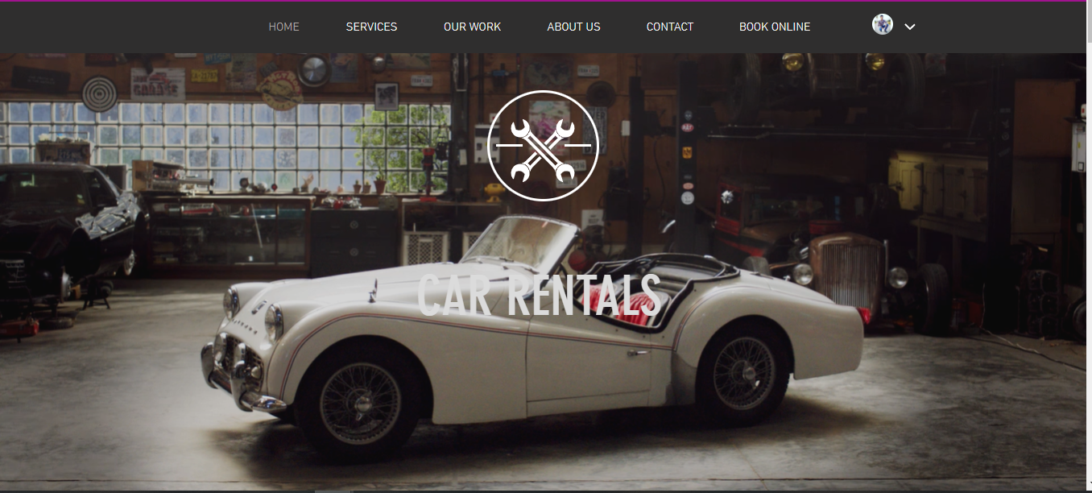

1. **LOG IN PAGE**

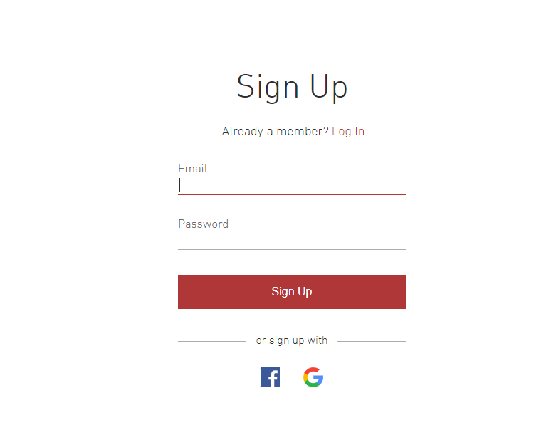

1. **SERVICES**

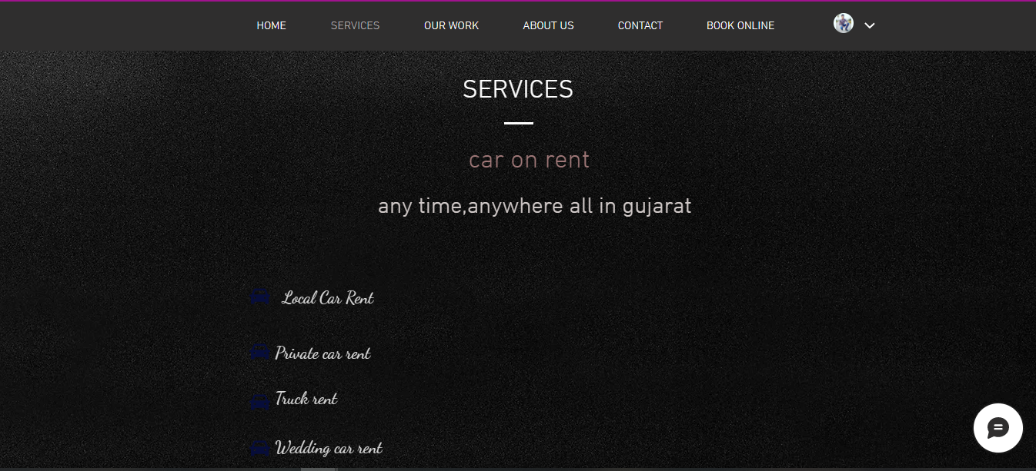

1. **BOOKING**

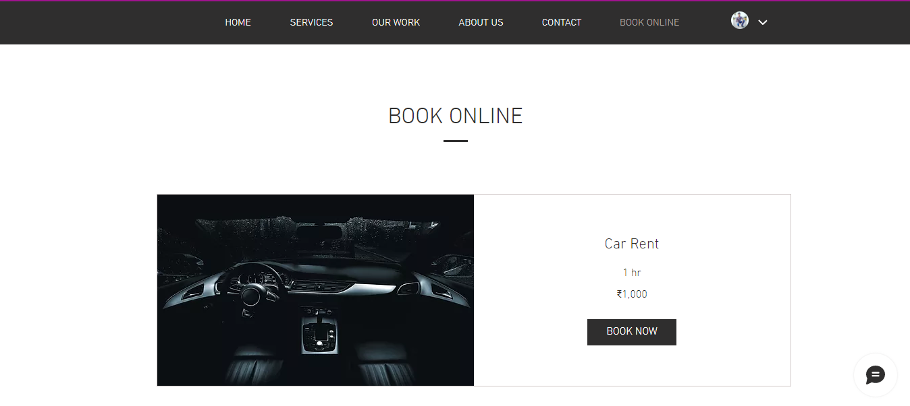

1. **About us**

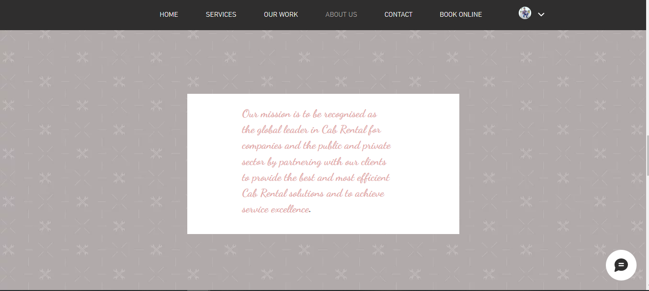

**FUNCTIONAL REQUIREMENTS:-**

1. User Registration – New users can register online on the website through either Google or Facebook.
2. Car Reservation – User/Customer is able to book or reserve a car online.
3. Automated Database System – The system will automatically update the database without any human effort.

**ANALYSIS:-**

It’s a website based on “Car Rental System”. It has a administrator who hasthe access of the whole system. Only he has the right to make changes in the database system regarding any activity on the website. First procedure is registration of new user. Each and every data will be stored in the database regarding cars, drivers, customers, etc.

**CONCLUSION:-**

This system is not only rewarding but helps the organizer to quicly and effectively organize the system and lists that too in less amount of time. It also makes easier to check details about any car or driver anywhere and on anytime. The system is also very user friendly and easy to use.

The user will not only enjoy but also will be satisfied by finding how wach and every feature is managed and implemented.

**REFERENCES:-**

1. [www.researchgate.net/publication/353174644_Car_Rental_System](http://www.researchgate.net/publication/353174644_Car_Rental_System)
2. <https://www.w3schools.com/mySQl/default.asp>
3. <https://www.simplilearn.com/tutorials/git-tutorial/what-is-github>
4. <https://ijirt.org/Article?manuscript=152529>